Understanding Dryer Vent Airflow: Why It Matters for Jacksonville Homes
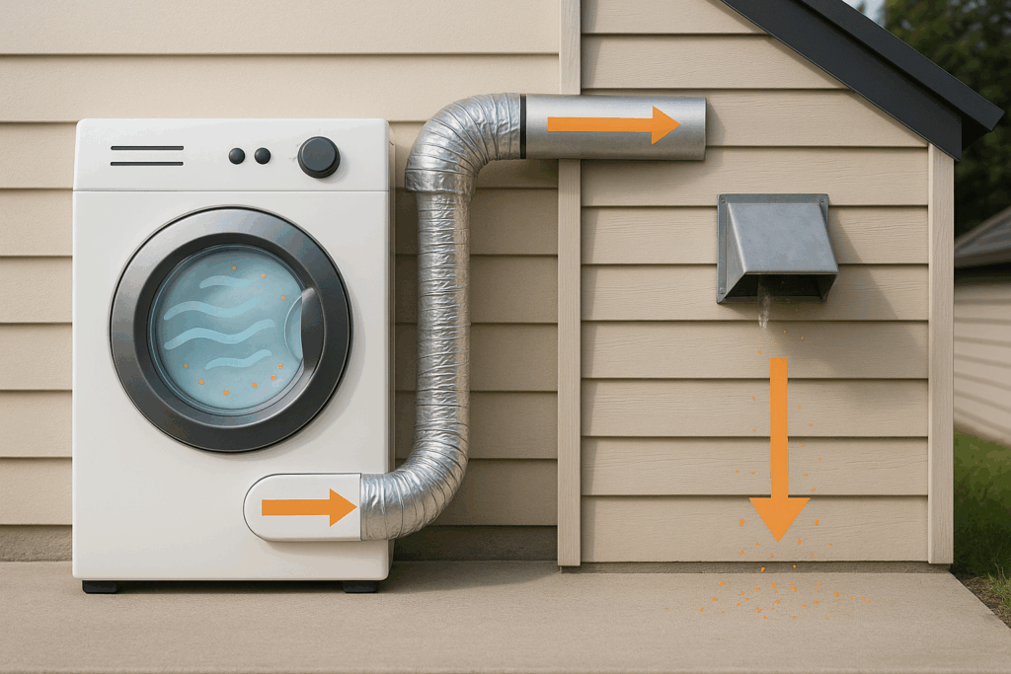
April 1 2026
When you toss a load of laundry into your dryer, the final step in the cycle carries moist air out of the drum and through the vent system. That stream of air is what we mean when we talk about dryer vent airflow. Most homeowners in Jacksonville and Neptune Beach focus on cleaning the lint screen; however, the vent performance plays an equally vital role in the efficiency and safety of your appliance. At Jax Dryer Vent Cleaning, LLC, we see how Florida humidity and coastal conditions impact these systems every day.
What Proper Airflow Looks Like
In a typical Northeast Florida residence, your dryer vent system begins in the laundry room and ends outside the building. As the dryer heats your clothes, exhaust mixed with moisture and lint travels through the ductwork. When airflow is clear, the vent carries that exhaust completely beyond the house. This prevents a buildup of heat and moisture inside your walls or attic.
Good airflow means the exhaust flows forcefully from the exterior exit. You should see the outside vent louvers open fully when the machine is running. You should not feel humid or warm air pooling in your laundry room. The International Association of Certified Home Inspectors notes that restricted airflow is a primary fire hazard because trapped lint causes the system to overheat.
Why Airflow Matters for Your Wallet
When your dryer exhausts smoothly, it finishes the job faster. Clothes dry in one cycle; you use less electricity; the machine lasts longer because it is not running for hours on end. If the vent path is blocked, the dryer stays at high temperatures for too long. For residents in Jacksonville and Atlantic Beach, this is a major factor in monthly utility costs. In our humid climate, moist air that stays trapped in the vent keeps your clothes damp and forces the dryer to work double time.
Why Airflow Matters for Safety
Airflow has a direct impact on the safety of your family. The warm air moving through your vent carries lint, which is highly flammable. If lint builds up inside the duct, it acts like kindling. The Consumer Product Safety Commission warns that fires can occur when the dryer internal temperature rises too high because the hot air has nowhere to go. This heat can migrate back toward the drum or the surrounding structure of your home.
Factors That Block Your Airflow
Duct material is a common issue. Flexible plastic or foil ducts are prone to crushing and sagging. We recommend rigid metal ducting to keep the air moving fast. The length of the vent also matters; more turns and longer runs make it harder for air to escape. In Florida, we also deal with exterior blockages like bird nests or heavy lint buildup on the outside flap. If you suspect a blockage, our Dryer Vent Inspection service can identify the exact location of the bottleneck.
Signs Your Vent Is Blocked
Spotting these issues early can save your appliance and protect your home. You might notice that clothes take more than one cycle to dry. The dryer itself might feel hot to the touch. You may see lint accumulating behind the machine or around the outside vent opening. A simple test is to go outside while the dryer is running; if the vent flaps are barely moving, you have an airflow problem that requires professional vent cleaning.
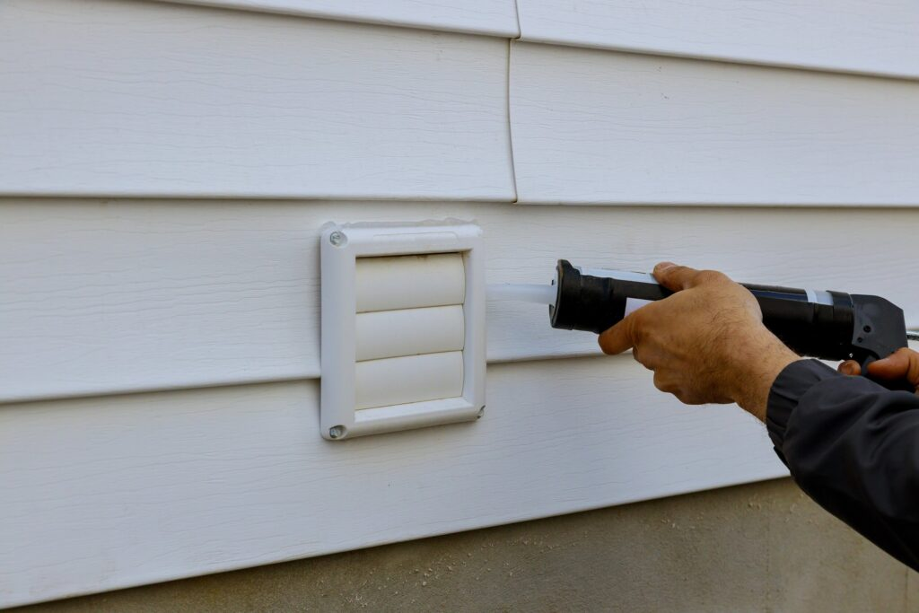
Protecting Your Indoor Air Quality
Jacksonville humidity makes mold a constant concern. If your dryer vent is leaking, it pumps gallons of water vapor back into your home. This creates a breeding ground for mold and musty smells in your laundry area. Proper venting ensures that moisture stays outside where it belongs.
What You Can Do Today
Clean the lint screen after every single load. Inspect the exterior vent monthly to ensure no birds have nested inside. Vacuum behind the dryer to prevent dust from being sucked into the internal heater. Always ensure the vent terminates outdoors rather than into a crawlspace or attic. If you are unsure where your vent leads, you can contact us for a consultation.
Professional Vent Cleaning
When standard maintenance is not enough, it is time to call in a professional. At Jax Dryer Vent Cleaning, LLC, we use specialized tools to clear the complex vent paths found in Florida homes. We do not just clear a clog; we optimize the entire path and ensure your system is safe.
Final Thoughts
Whether you live in a house in Jacksonville or a condo on Neptune Beach, your dryer vent deserves attention. Keeping the air moving improves efficiency and saves money. If your dryer is running hot or taking too long, do not wait for a fire. Visit our homepage to learn more or schedule an appointment to get your laundry room back in shape.

